Nikhil Satpute 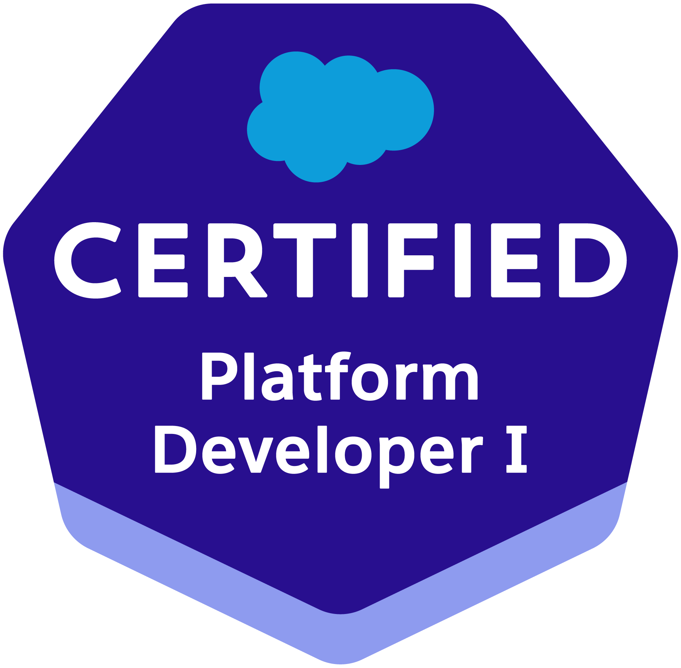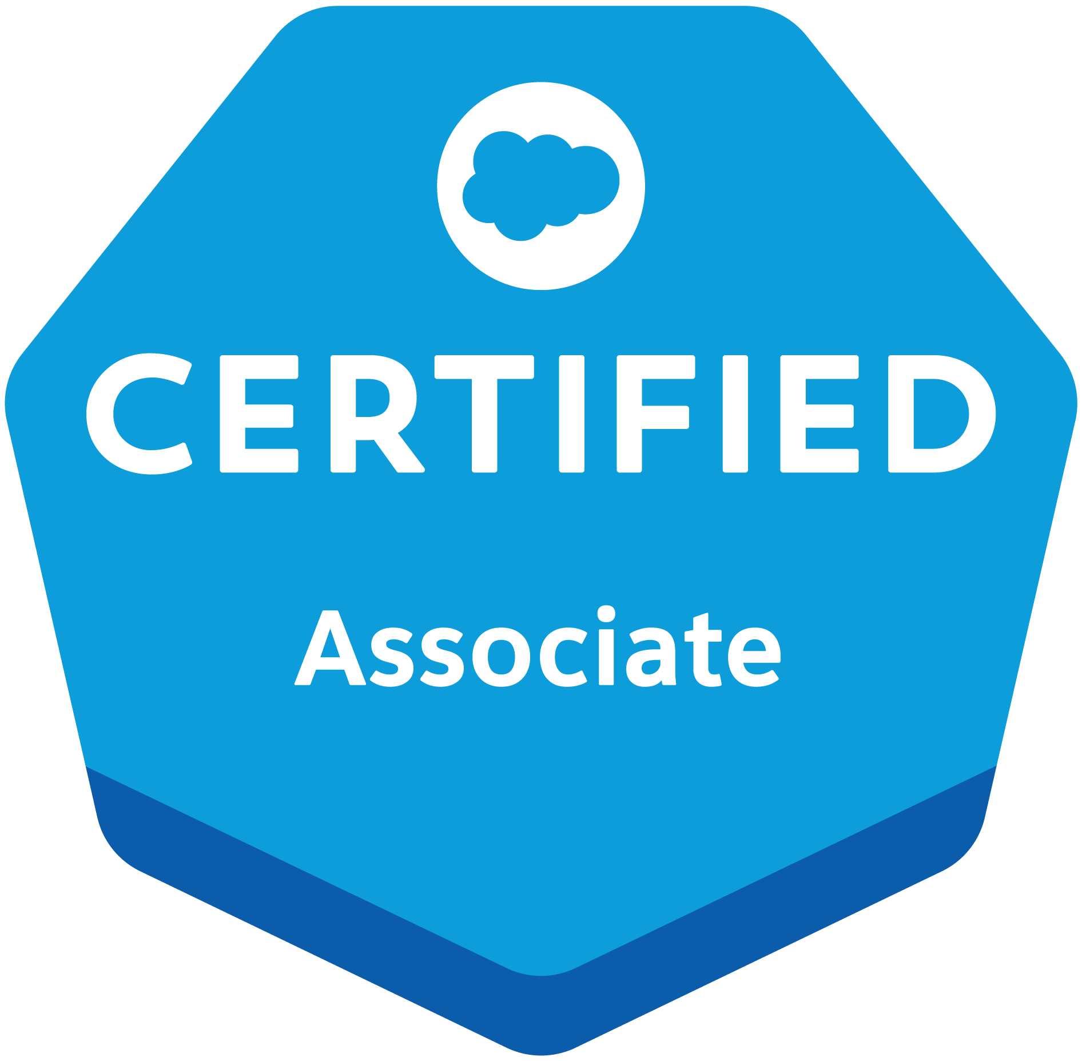
9607357648 | nikhilaksatpute@gmail.com | https://www.linkedin.com/in/nikhilasatpute | https://www.salesforce.com/trailblazer/amdit
PROFESSIONAL SUMMARY
Highly skilled and experienced Salesforce developer with a strong background in building and customizing Salesforce applications. Possesses expertise in various Salesforce technologies, including HTML, CSS, Javascript, Process Builder, Workflow, Apex (including Apex Classes and Apex Triggers), Lightning Web Component, and Visualforce. The candidate is proficient in data modeling, Apex Data Loader, and data migration. Possesses strong knowledge of SOQL and are skilled in building effective and informative dashboards and reports to help businesses make data-driven decisions.
EXPERIENCE
Salesforce Developer : Percept Infosystems Nagpur January 2023 - December 2023
- Project: Lead Conversion Process in Salesforce Sales Cloud
  - Role: Salesforce Trainee Developer
  - Technologies Used: Salesforce Sales Cloud, Apex, Visualforce, Lightning Web Components (LWC), SOQL, Data Loader, Salesforce Reports and Dashboards
  - Responsibilities:
    - Designed and developed custom Salesforce applications to enhance the lead conversion process.
    - Created and customized Salesforce objects, fields, and workflows to streamline lead management.
    - Developed Apex classes and triggers to automate lead conversion and data handling.
    - Built Lightning Web Components (LWC) for a more dynamic user experience and enhanced UI.
    - Integrated Salesforce with external systems to ensure seamless data flow.
    - Produced detailed documentation and conducted training sessions for end-users to facilitate smooth adoption of new features.
    - Monitored and optimized system performance and resolved any technical issues.

Associate RF Engineer: AMDOCS ,PUNE January 2022 - December 2022
- Developed and executed a comprehensive fiber network drafting strategy, resulted in a 25% reduction in drafting errors and a 15% increase in drafting efficiency.
- Orchestrated the implementation of ARAMIS, FTTx, and FTTH fiber planning systems, resulted in a 40% reduction in deployment time and a 30% increase in project completion rate.
Application Engineer: ARTEMIS PVT. LTD. ,PUNE October 2021 - January 2022
- Exhibiting strong technical aptitude and application expertise resulting in optimized performance, continuous improvement recommendations and product innovation.
- Partnered with the development team on product development and application support plans. Visited clients to determine feasibility, analyze requirements and provide solution suggestions.

Skills
- Salesforce Technologies: Salesforce Sales Cloud, Apex, Visualforce, Lightning Web Components (LWC), SOQL, Salesforce Reports and Dashboards
- Support Platforms: ServiceNow
- Programming Languages: Apex,HTML, CSS, JavaScript (for LWC), SQL
- Tools: Salesforce Data Loader, JIRA, Excel
- Project Management: Requirement Gathering, Process Improvement, User Training

PROJECTS
Lead Conversion Enhancement:
- Description: Optimized the lead conversion process within Salesforce Sales Cloud to improve efficiency and accuracy.
- Responsibilities: Customized Salesforce features, developed automation scripts, and created dynamic reports.
- Impact: Achieved a 20% reduction in ticket resolution time through process optimization and automation.

CERTIFICATIONS
● Platform Developer I, Trailhead (2023)
● Salesforce Certified Associate, Trailhead (2023)
● Industrial automation certification, 2021

Education
B.E. Electrical | Jspm’s RSCOE, Pune | 7.57 CGPA | 2021
Class XII, HSC | ACS college Chandrapur | 67.69% | 2017
Class X, CBSE | BJM Carmel academy, Chandrapur | 8.8 CGPA | 2015

